27.8: a)
Set this equal to the given value of 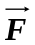to obtain:

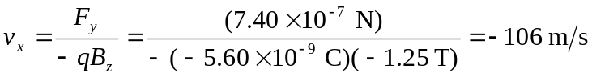
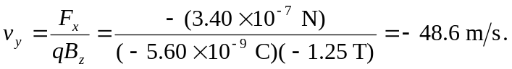

b) The value of 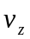is indeterminate.
c) 